**Assignment 02 DDL**

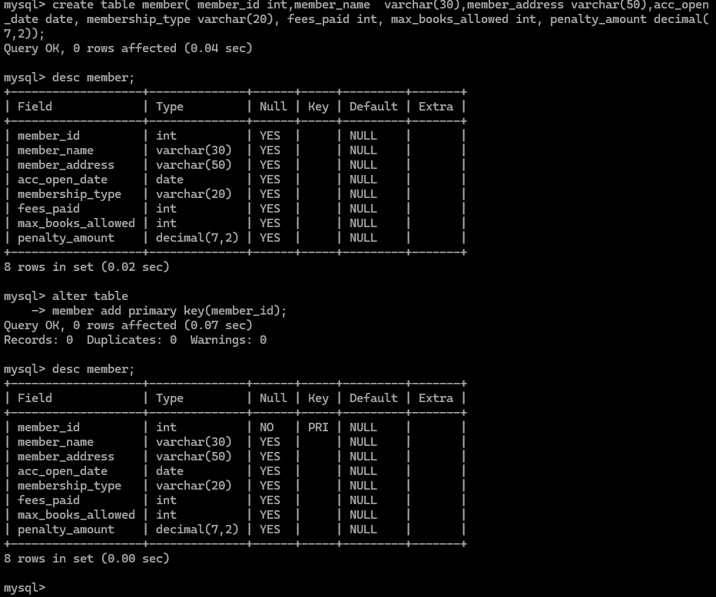

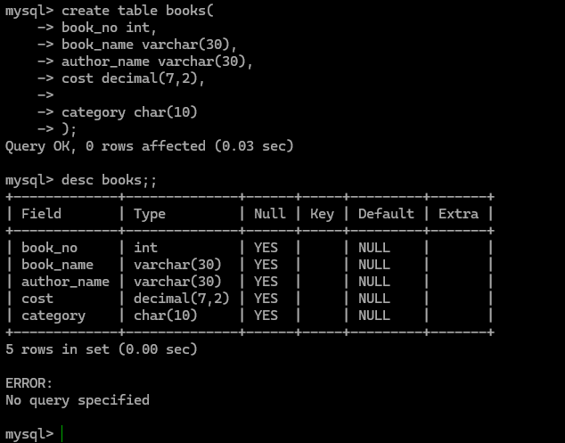

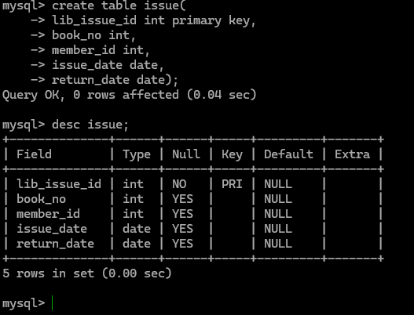

4. b

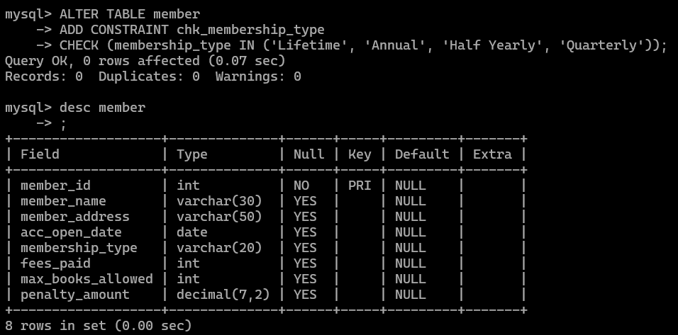

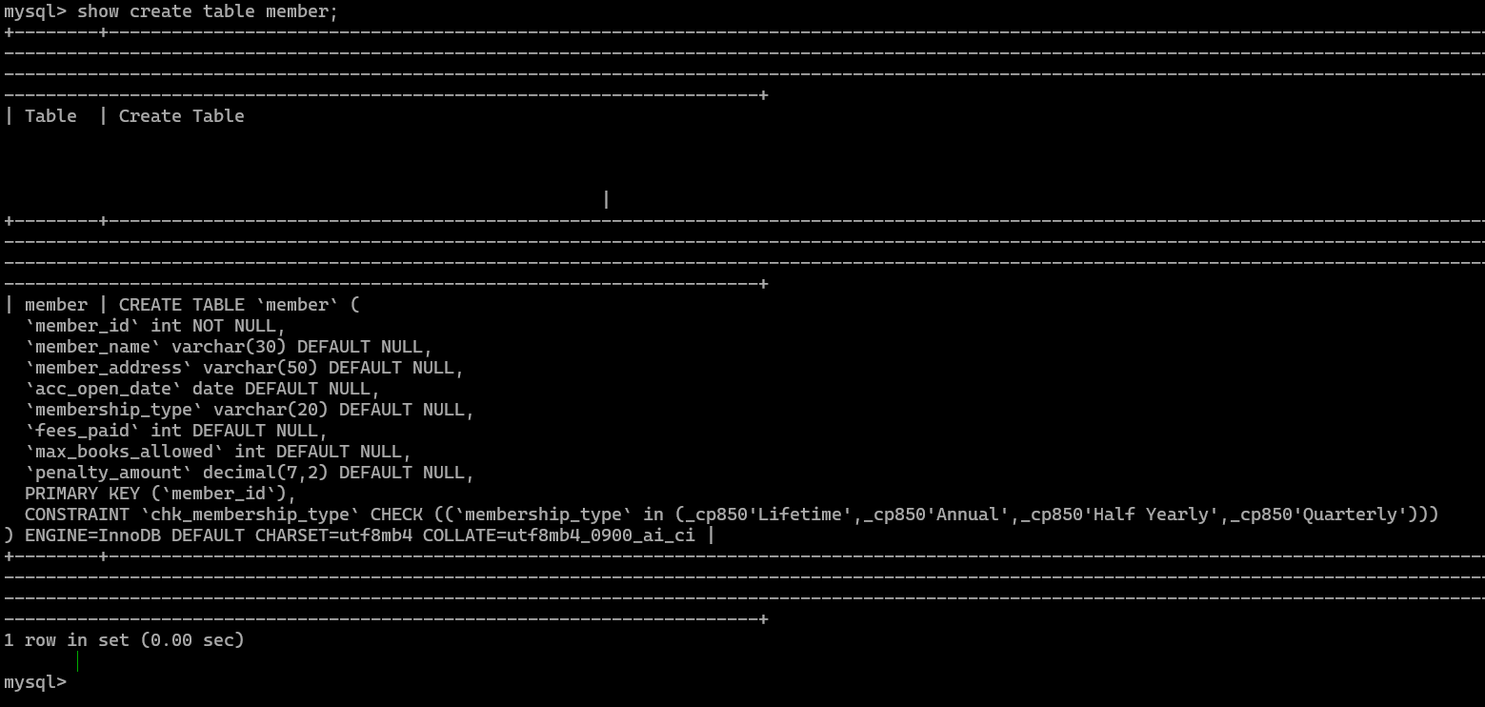

5.

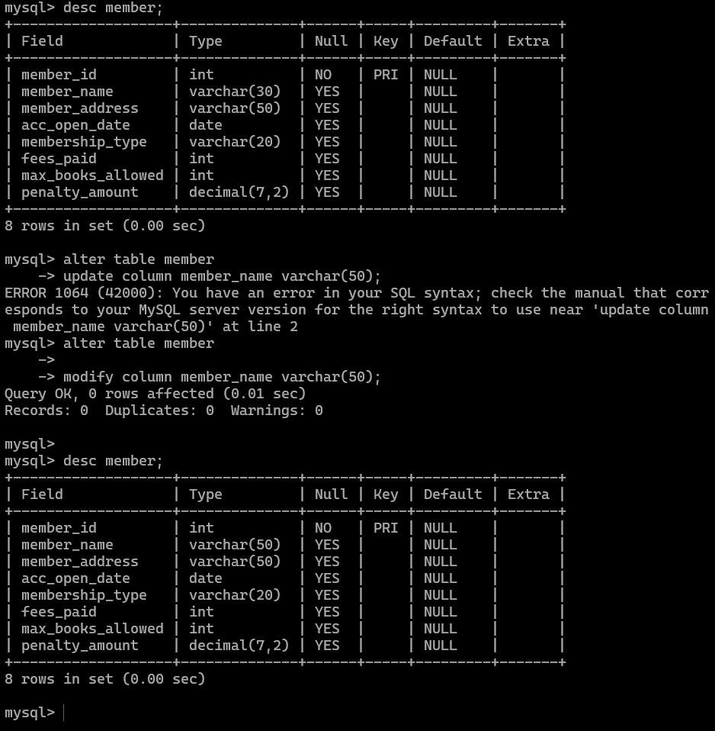

6: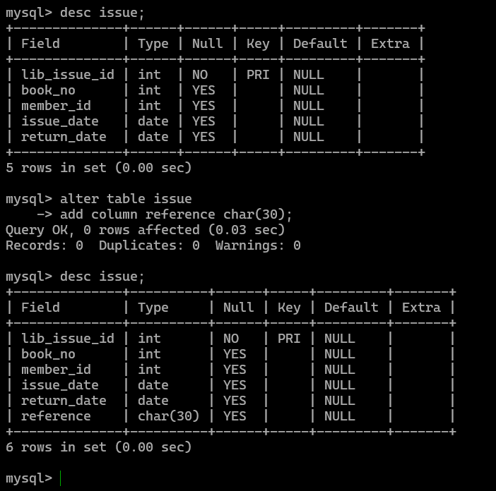

7: 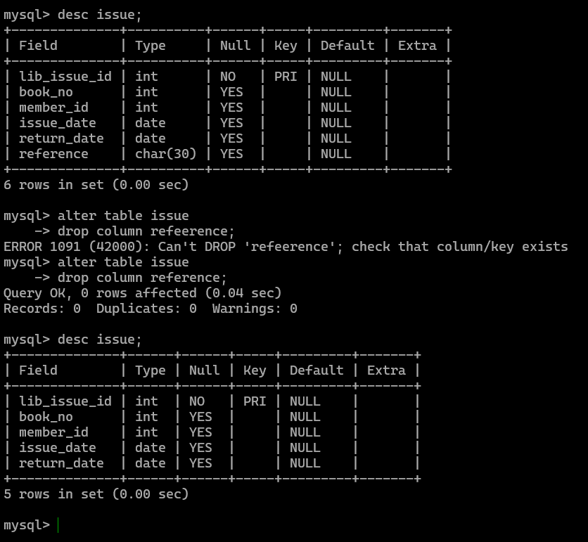

8.

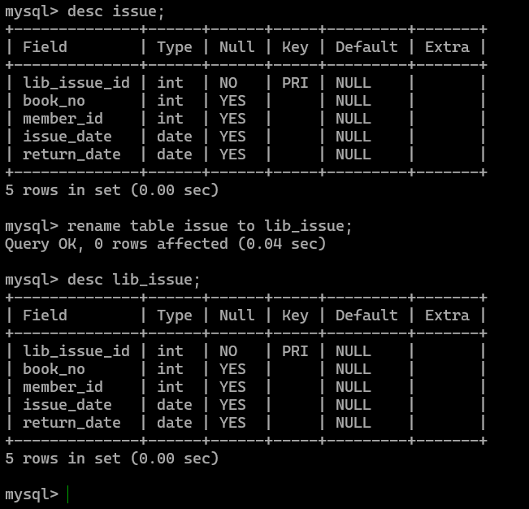

9

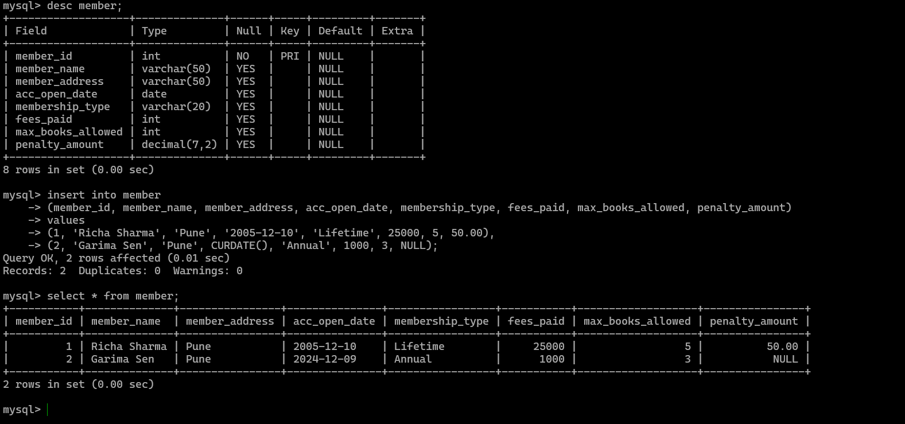

**10.**

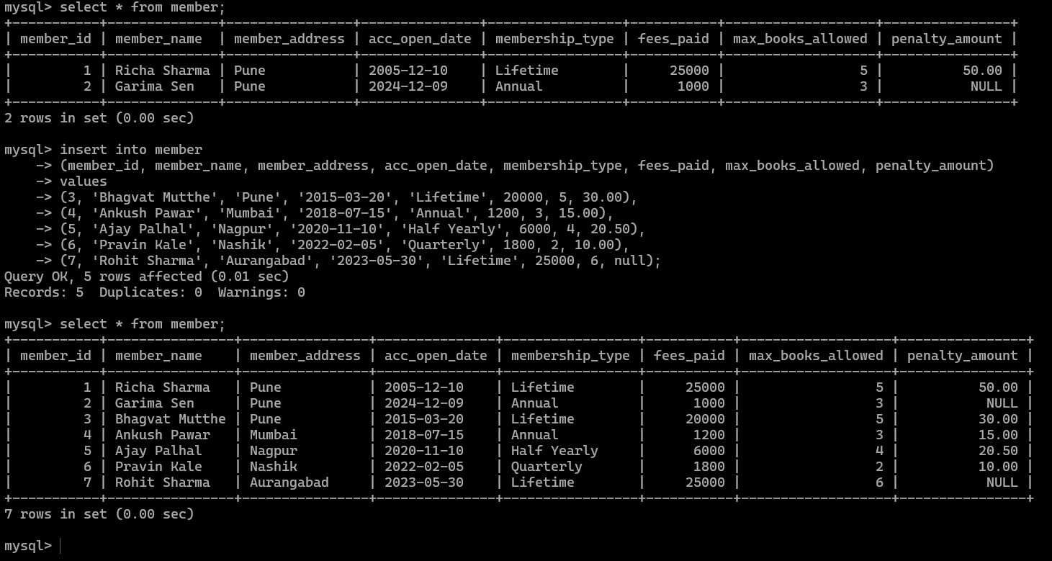

**11 >**

**mysql> alter table member**

**-> modify column member_name varchar(20);**

**Query OK, 7 rows affected (0.16 sec)**

**Records: 7 Duplicates: 0 Warnings: 0**

**mysql> desc member;**

**+-------------------+--------------+------+-----+---------+-------+**

**| Field | Type | Null | Key | Default | Extra |**

**+-------------------+--------------+------+-----+---------+-------+**

**| member_id | int | NO | PRI | NULL | |**

**| member_name | varchar(20) | YES | | NULL | |**

**| member_address | varchar(50) | YES | | NULL | |**

**| acc_open_date | date | YES | | NULL | |**

**| membership_type | varchar(20) | YES | | NULL | |**

**| fees_paid | int | YES | | NULL | |**

**| max_books_allowed | int | YES | | NULL | |**

**| penalty_amount | decimal(7,2) | YES | | NULL | |**

**+-------------------+--------------+------+-----+---------+-------+**

**8 rows in set (0.03 sec)**

**mysql> alter table member**

**-> modify column member_name char(20);**

**Query OK, 7 rows affected (0.11 sec)**

**Records: 7 Duplicates: 0 Warnings: 0**

**mysql> desc member;**

**+-------------------+--------------+------+-----+---------+-------+**

**| Field | Type | Null | Key | Default | Extra |**

**+-------------------+--------------+------+-----+---------+-------+**

**| member_id | int | NO | PRI | NULL | |**

**| member_name | char(20) | YES | | NULL | |**

**| member_address | varchar(50) | YES | | NULL | |**

**| acc_open_date | date | YES | | NULL | |**

**| membership_type | varchar(20) | YES | | NULL | |**

**| fees_paid | int | YES | | NULL | |**

**| max_books_allowed | int | YES | | NULL | |**

**| penalty_amount | decimal(7,2) | YES | | NULL | |**

**+-------------------+--------------+------+-----+---------+-------+**

**8 rows in set (0.00 sec)**

**mysql> select * from member;**

**+-----------+----------------+----------------+---------------+-----------------+-----------+-------------------+----------------+**

**| member_id | member_name | member_address | acc_open_date | membership_type | fees_paid | max_books_allowed | penalty_amount |**

**+-----------+----------------+----------------+---------------+-----------------+-----------+-------------------+----------------+**

**| 1 | Richa Sharma | Pune | 2005-12-10 | Lifetime | 25000 | 5 | 50.00 |**

**| 2 | Garima Sen | Pune | 2024-12-09 | Annual | 1000 | 3 | NULL |**

**| 3 | Bhagvat Mutthe | Pune | 2015-03-20 | Lifetime | 20000 | 5 | 30.00 |**

**| 4 | Ankush Pawar | Mumbai | 2018-07-15 | Annual | 1200 | 3 | 15.00 |**

**| 5 | Ajay Palhal | Nagpur | 2020-11-10 | Half Yearly | 6000 | 4 | 20.50 |**

**| 6 | Pravin Kale | Nashik | 2022-02-05 | Quarterly | 1800 | 2 | 10.00 |**

**| 7 | Rohit Sharma | Aurangabad | 2023-05-30 | Lifetime | 25000 | 6 | NULL |**

**+-----------+----------------+----------------+---------------+-----------------+-----------+-------------------+----------------+**

**7 rows in set (0.00 sec)**

**mysql>**

**12.**

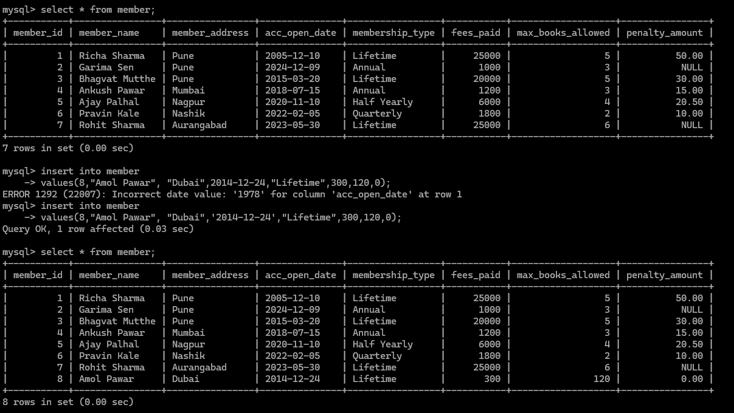

**13.** 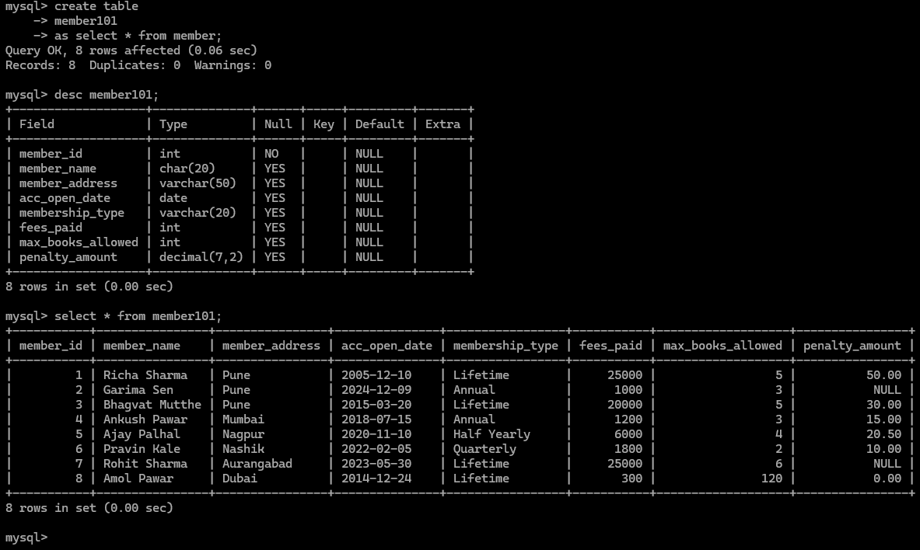

**14.**

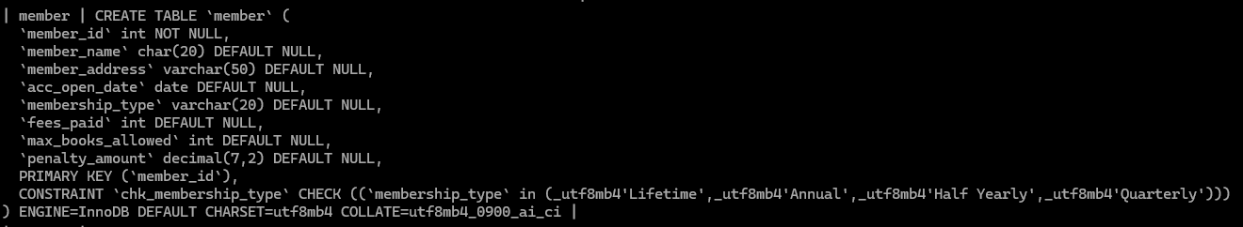

**15.**

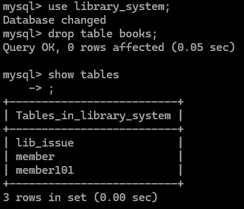

**16:**

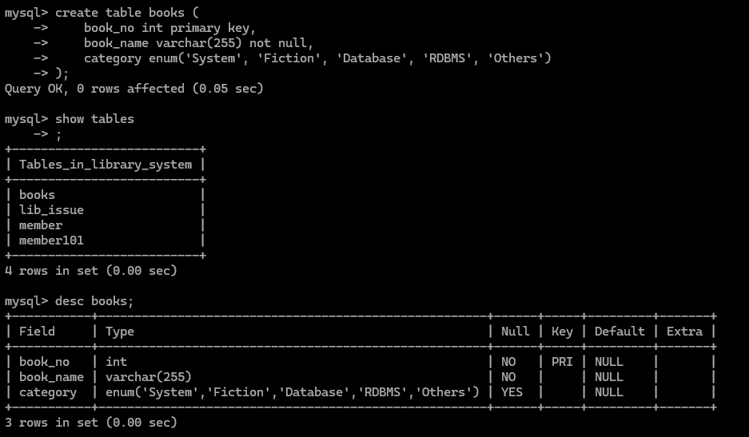

**17.**

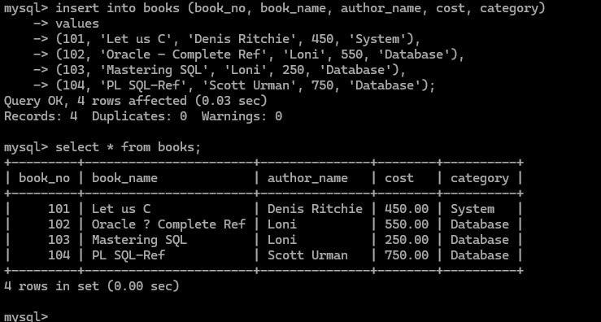

**18 19**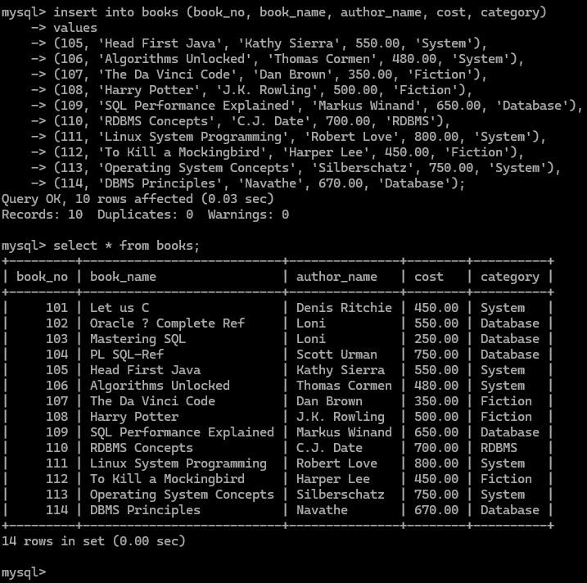

**20**

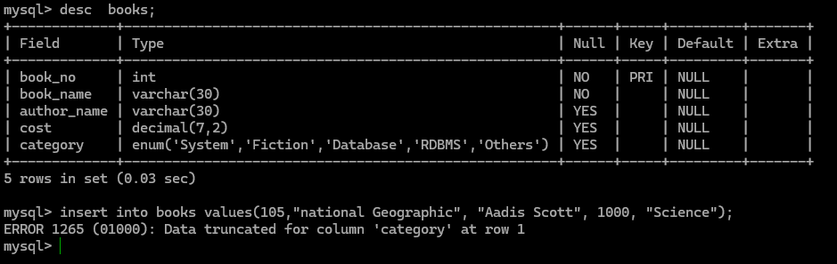

**21.**

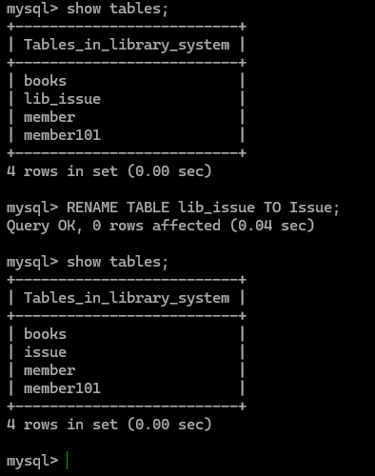

**22**

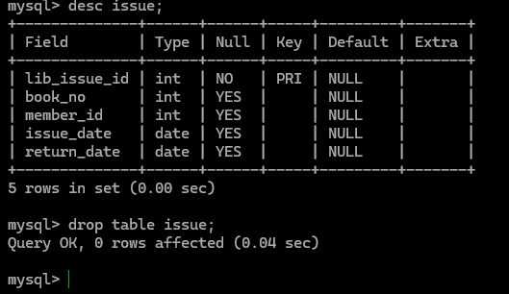

**23**

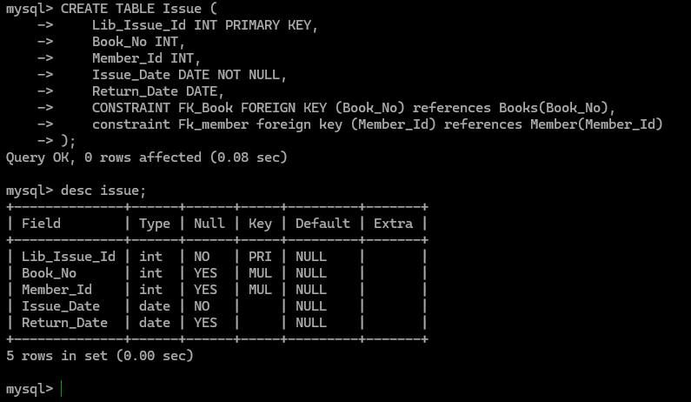

**24**

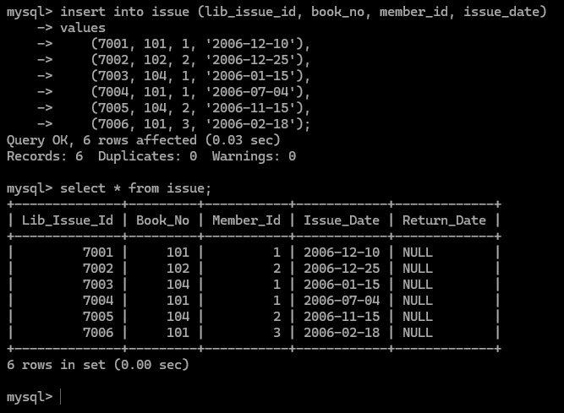

**25**

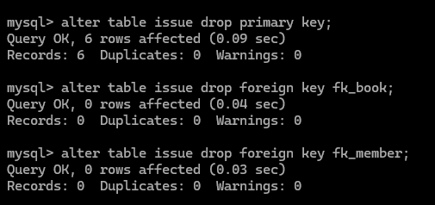

**26**

**mysql> insert into issue (lib_issue_id, book_no, member_id, issue_date)**

**-> values (7007, 103, 999, '2006-12-20');**

**Query OK, 1 row affected (0.00 sec)**

**mysql> select * from issue;**

**+--------------+---------+-----------+------------+-------------+**

**| Lib_Issue_Id | Book_No | Member_Id | Issue_Date | Return_Date |**

**+--------------+---------+-----------+------------+-------------+**

**| 7001 | 101 | 1 | 2006-12-10 | NULL |**

**| 7002 | 102 | 2 | 2006-12-25 | NULL |**

**| 7003 | 104 | 1 | 2006-01-15 | NULL |**

**| 7004 | 101 | 1 | 2006-07-04 | NULL |**

**| 7005 | 104 | 2 | 2006-11-15 | NULL |**

**| 7006 | 101 | 3 | 2006-02-18 | NULL |**

**| 7007 | 103 | 999 | 2006-12-20 | NULL |**

**+--------------+---------+-----------+------------+-------------+**

**7 rows in set (0.00 sec)**

**27**

**mysql> alter table issue**

**-> add constraint pk_lib_issue primary key (lib_issue_id);**

**Query OK, 0 rows affected (0.10 sec)**

**Records: 0 Duplicates: 0 Warnings: 0**

**mysql> alter table issue**

**-> add constraint fk_book foreign key (book_no) references books(book_no);**

**Query OK, 7 rows affected (0.11 sec)**

**Records: 7 Duplicates: 0 Warnings: 0**

**mysql> alter table issue**

**-> add constraint fk_member foreign key (member_id) references member(member_id);**

**ERROR 1452 (23000): Cannot add or update a child row: a foreign key constraint fails (`library_system`.`#sql-18a0_8`, CONSTRAINT `fk_member` FOREIGN KEY (`Member_Id`) REFERENCES `member` (`member_id`))**

**mysql>**

**28:**